**Lab report 04**



**CSE 402L**

**Digital Signal Processing Fall 2024**

**Submitted by: Naveed Ahmad**

**Registration No.: 22PWCSE2165**

**Class Section: B**

**Semester :5th**

*“On my honor , as student of University of Engineering and Technology, I have neither given nor received unauthorized assistance on this academic work”*

Student Signature: ____________

Submitted to:

**Dr. Yasir Saleem Afridi**

Nov. 25, 2024

Department of Computer Systems Engineering

University of Engineering and Technology Peshawar

Task:

Will generate the signal of different frequencies say , 10,20,30,40,50,60 Hz (one second duration) using Matlab as shown in figure 1 and transform the same signal in frequency domain using Fourier transform and will compare the frequencies with the time domain signal as shown in figure 2.

Code:

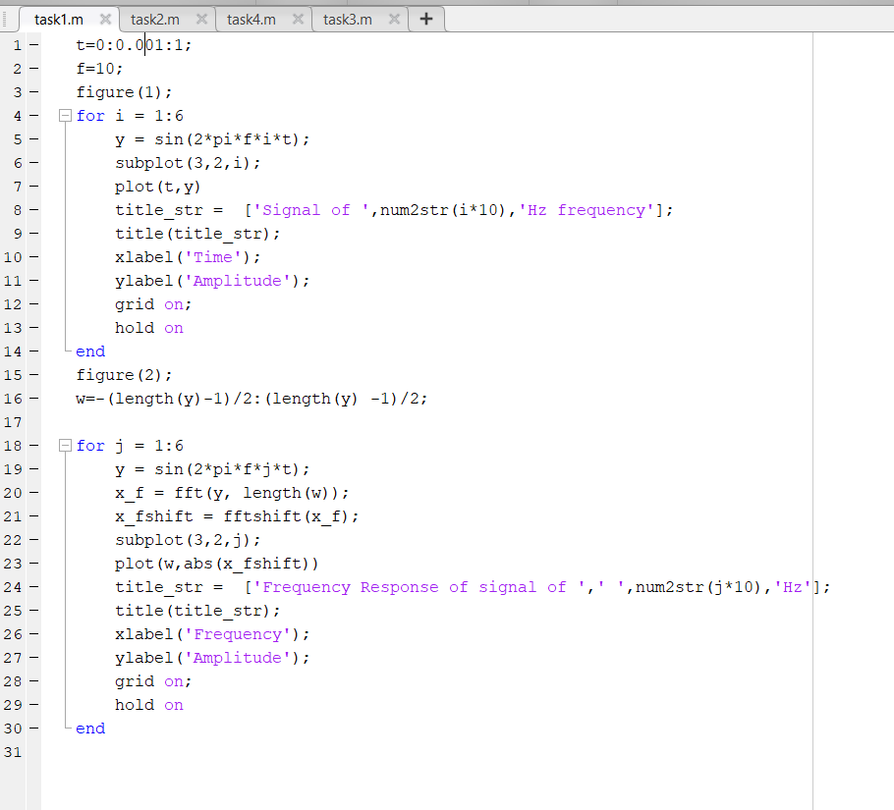

* Time vector t defined, representing time from 0 to 1.
* Base frequency f set as 10 Hz.
* Figure 1 displays sine waves of increasing frequencies.
* Each subplot shows a signal's time-domain representation.
* Figure 2 analyzes and plots frequency-domain responses.
* Frequency vector w defined for FFT centering.
* FFT calculates and plots signal magnitude spectrums.

Output:

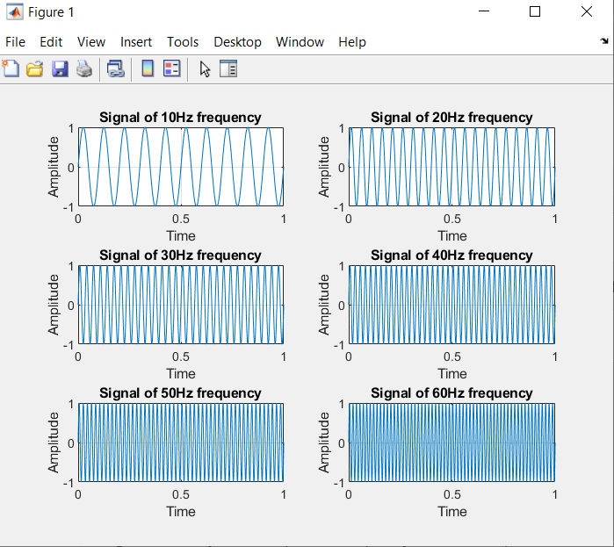

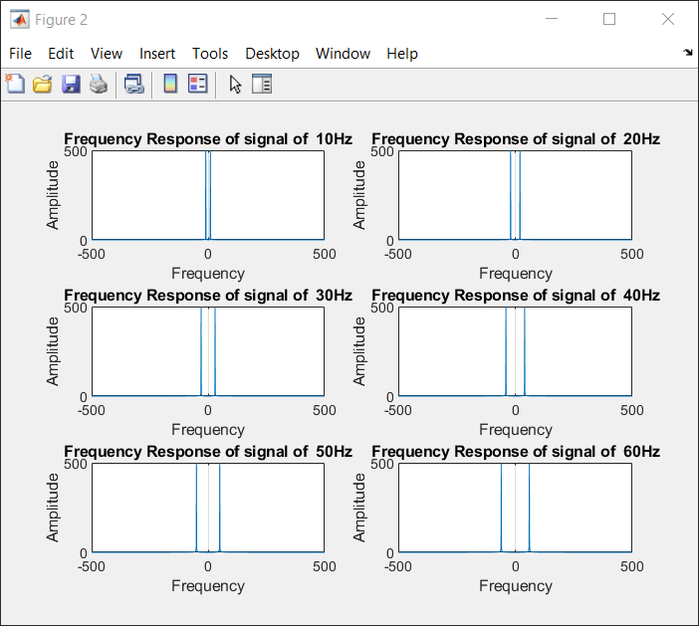

Task 02:

* **Compare** the Figures 1 and 2 (Generated by your code)
* Add all the signals generated in step 1 and get a composite signal. (which may be considered as a voice signal)
* Plot the time and frequency domain representation of the composite signal as shown in Figure 3

Code:

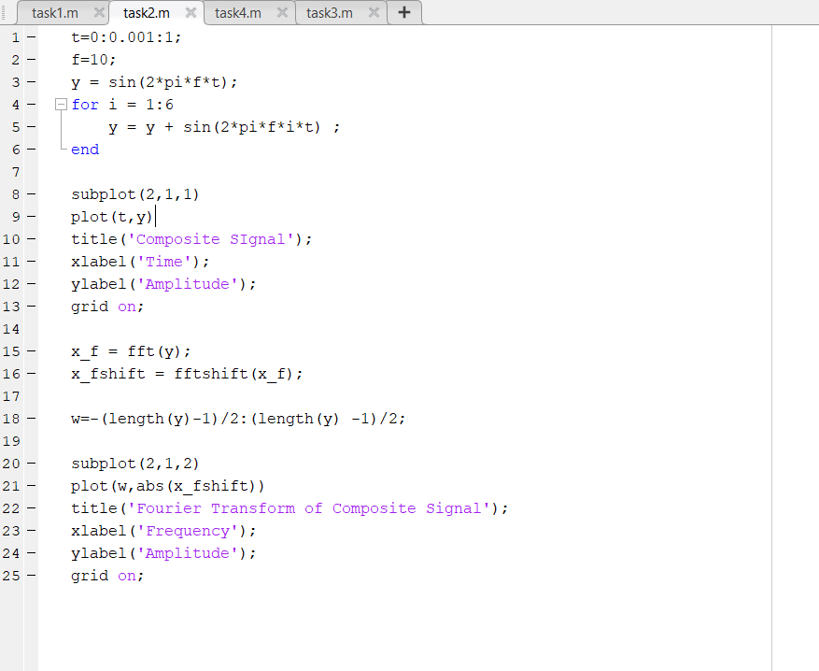

* Time vector t defined from 0 to 1 with 0.001 step size.
* Base frequency f set as 10 Hz.
* Initial sine wave y defined for base frequency.
* Loop adds harmonics to create a composite signal.
* First subplot plots the composite signal in the time domain.
* Title, labels, and grid added for clarity.
* FFT applied to composite signal to analyze frequency domain.
* Frequency vector w defined for centered spectrum.
* Second subplot plots magnitude of Fourier Transform.

Output:

